Super Market Sales Analysis
Paola Andrea Gomez, Chinmaya Katagondanahalli, Priyanka Kulkarni, Vetrivel Kumar
Group 3
INFO584_97SP25
Professor Serhat Simsek
March 9 2025

Table of contents
Abstract
Introduction/Motivation…
Data Set
Analysis
Results
Limitations of study and conclusion…
References

Abstract
This report examines supermarket sales data to explore customer purchasing behavior, revenue trends, and profitability across multiple product lines and store branches. Through a structured analysis, the study identifies key patterns in sales performance, payment methods, and customer preferences. The analysis demonstrates how data visualization can support decision-making in areas such as inventory management, pricing strategies, and customer retention. Insights derived from this study provide valuable recommendations to enhance operational efficiency and optimize revenue generation for supermarkets. Additionally, this study explores how supermarket managers can use data-driven insights to improve customer engagement and boost overall sales through targeted strategies.
Introduction/Motivation
Supermarkets are dynamic retail environments where consumer preferences and sales trends influence profitability. With evolving market conditions, businesses must leverage data analytics to make informed decisions regarding product assortment, store layout, and customer engagement strategies. Understanding customer purchasing behavior and sales patterns can help retailers adapt to changing consumer demands and develop tailored marketing approaches.
The purpose of this study is to identify:
- The highest revenue-generating product lines and the factors contributing to their success.
- The impact of customer type (Member vs. Normal) on purchase behavior.
- The influence of payment methods on transaction value and frequency.
- Time-based sales trends to optimize store operations and staffing schedules.
- Variations in sales performance across different branches and their contributing factors.
By conducting an in-depth analysis, this study aims to provide supermarket stakeholders with actionable insights that can support strategic decision-making and drive business growth.
Data Set
The dataset comprises 1,000 supermarket transactions collected from various store locations. It contains essential details about customer purchases, including sales data, demographics, product categories, and payment methods. The key attributes include:
- Transaction Details: Invoice ID, Date, Time, Branch, City
- Customer Information: Customer Type (Member/Normal), Gender
- Product Details: Product Line, Unit Price, Quantity
- Financial Metrics: Tax (5%), Total Sales, Cost of Goods Sold (COGS), Gross Margin Percentage, Gross Income
- Other Attributes: Payment Method, Customer Rating
This dataset provides an in-depth view of supermarket transactions, allowing for the examination of revenue streams, consumer purchasing trends, and operational performance. The inclusion of financial metrics such as Gross Income and Cost of Goods Sold enables an analysis of profitability across different product lines.
Data Preparation and Cleaning
To ensure the accuracy and reliability of the analysis, the following preprocessing steps were performed:
- Date and Time Processing: The Date column was standardized into a consistent format, and the Time column was used to extract the hour of purchase. This allowed for an analysis of peak shopping hours and daily sales trends.
- Missing Data Handling: The dataset was examined for missing values to ensure completeness. No significant missing values were found.
- Data Transformation: The Gross Margin Percentage column was reformatted to ensure accurate percentage calculations. This helped to analyze the profitability of different product lines.
- Aggregation of Key Metrics: To facilitate analysis, total revenue, gross income, and average customer spending per transaction were computed. These aggregations provided a clearer understanding of sales performance.
These data preprocessing steps ensured that the dataset was structured correctly for effective analysis and visualization, allowing for more accurate insights into supermarket sales trends.
Analysis
The data was analyzed using various methods to uncover trends and patterns in supermarket sales performance. The key areas of analysis included:
- Revenue Breakdown by Product Line:
  - Analyzed which product categories contribute the most to total revenue and profitability.
  - Evaluated the percentage contribution of each category to overall sales.

- Branch-Wise Sales Performance:
  - Compared sales trends across different store locations to identify top-performing branches.
  - Examined whether specific branches had higher revenue due to customer demographics or location advantages.
  - Analyzed how each branch contributes to total company revenue.
- Customer Spending Patterns:
  - Examined spending behavior by customer type (Members vs. Non-Members) to determine whether loyalty programs influence purchase behavior.
  - Evaluated the average transaction value for each customer category.
  - Identified peak shopping days of the week to optimize store operations and staffing schedules.
  - Compared sales trends during weekdays versus weekends.
- Impact of Payment Methods:
  - Assessed the correlation between payment methods and transaction value.
  - Evaluated customer preferences for credit cards, e-wallets, and cash transactions.
  - Determined which payment method is associated with higher transaction amounts.
- Customer Ratings and Satisfaction:
  - Explored trends in customer ratings to identify areas for improvement in service and product quality.
  - Assessed the relationship between product quality, customer satisfaction, and repeat purchases.
  - Examined which product lines received the highest and lowest ratings.

Results
The analysis of top-selling product lines revealed that Food and Beverages generated the highest revenue, contributing 17.38% of total sales. This category was followed by Sports and Travel, accounting for 17.06% of revenue, and Electronic Accessories, which comprised 16.82% of sales. The strong consumer demand for these product lines highlights their significance in revenue optimization and inventory planning.
The revenue distribution among product lines suggests that supermarkets should prioritize these categories in promotional strategies and stock management. Given the high consumer interest in Food and Beverages, implementing targeted marketing campaigns, discounts, or loyalty rewards in this category could further boost sales. Similarly, monitoring sales trends in Sports and Travel and Electronic Accessories may help supermarkets adjust pricing strategies or introduce related product bundles to maximize revenue potential.
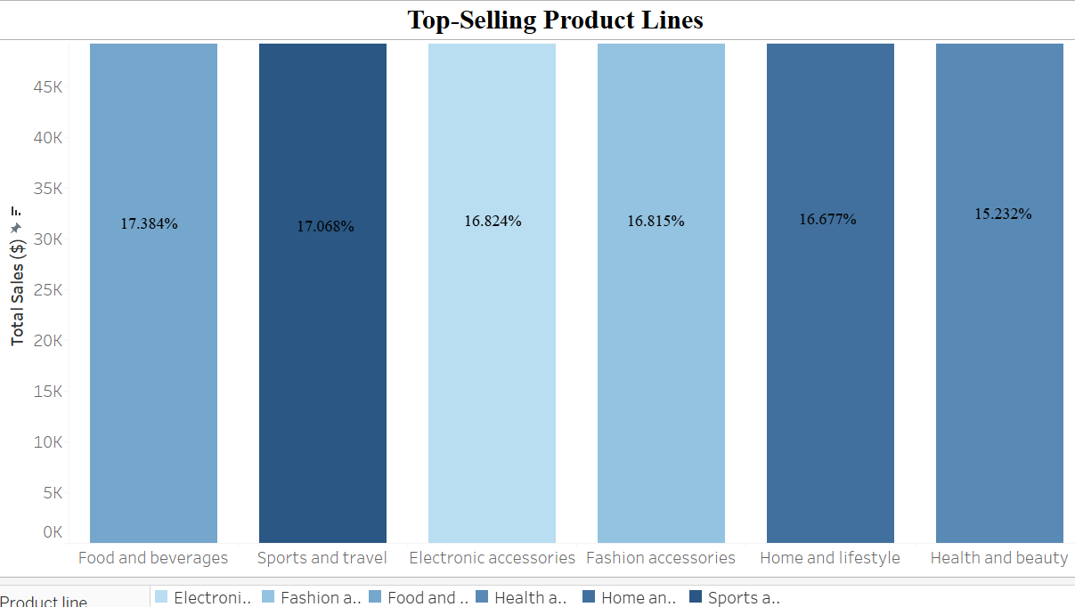
Tableau Dashboard Link: Supermarket Sales Analysis | Tableau Public
After identifying the top-selling product lines, the analysis shifts to comparing sales across different store locations in Myanmar: Mandalay, Naypyitaw, and Yangon. Each branch is represented by a unique letter (A, B, or C), providing an at-a-glance view of how location and store-specific factors influence revenue generation. The table below breaks down sales by product line for each branch, highlighting notable variations such as higher demand for Food and Beverages in Naypyitaw compared to Mandalay, or stronger sales of Electronic Accessories in Yangon.

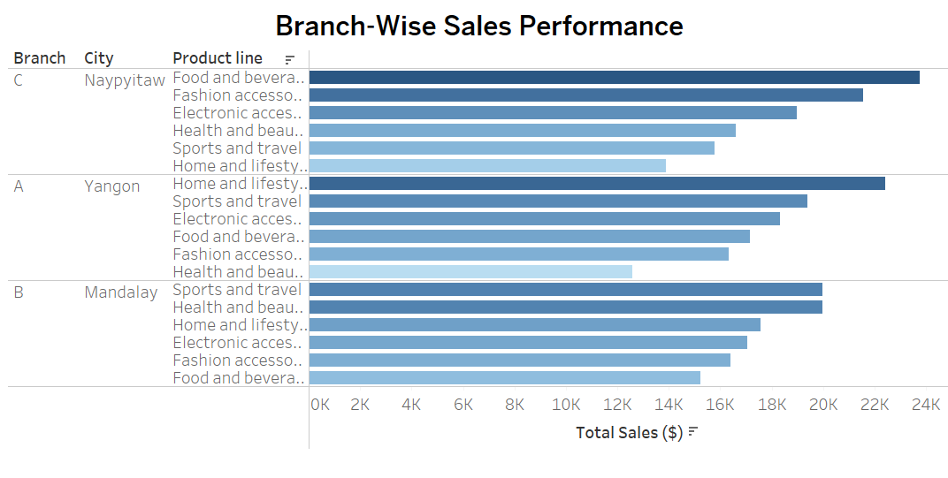Tableau Dashboard Link: Branch-Wise Sales Performance | Tableau Public
By examining these branch-specific sales figures, supermarket managers can identify regional preferences and capitalize on potential growth opportunities. Branches with higher sales in certain categories may benefit from additional promotions or targeted stock replenishment, while locations showing lower performance might need adjusted product mixes, price incentives, or localized marketing efforts. This data-driven approach ensures that each store can refine its strategies according to local customer preferences and competitive conditions, ultimately boosting profitability across the entire supermarket chain.
Customer Spending Patterns:
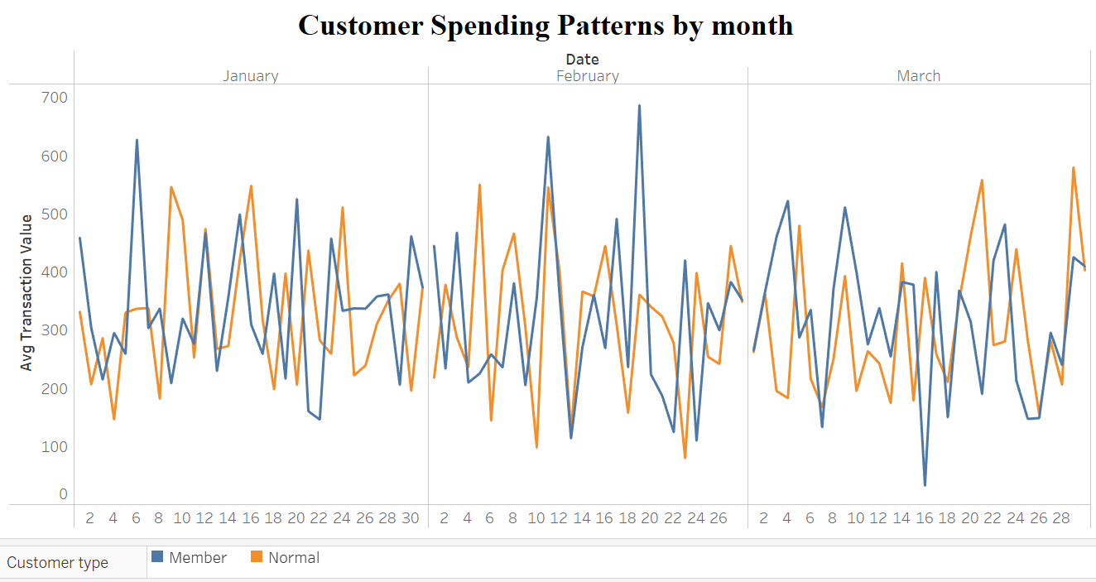
Tableau Dashboard Link: Customer Spending Patterns by month | Tableau Public

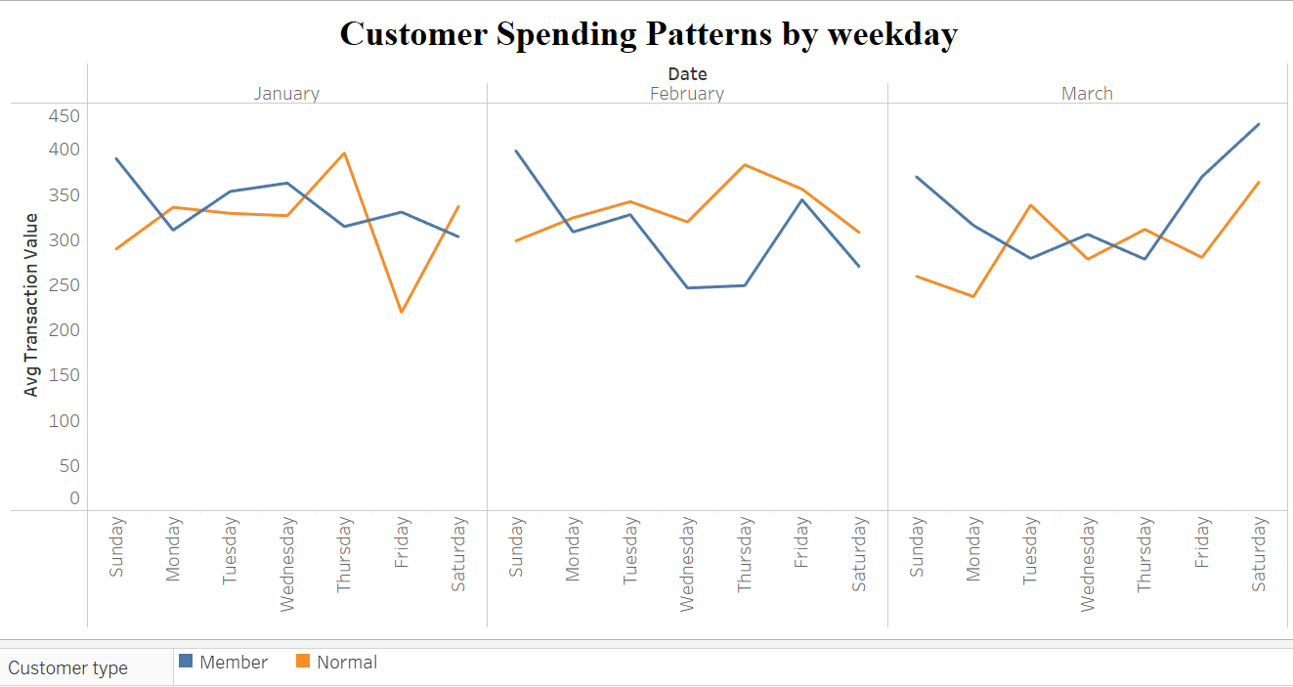
Tableau Dashboard Link: Customer Spending Patterns by weekday | Tableau Public
After comparing spending behavior for Members and Non-Members from January through March, the analysis revealed that Members generally spent slightly more per transaction than Non-Members. By calculating the average transaction value for each category, the data confirms that loyalty programs may positively influence spending, as evidenced by the consistently higher amounts recorded in Member transactions.
The study also examined weekday patterns to determine if there were any notable spikes or dips across days. The line chart indicates that Friday and Saturday often exhibit the highest average transaction values, suggesting that these days are prime for increased staffing and strategic promotions. When comparing weekday versus weekend performance, the findings show that weekends (especially Fridays) tend to present more significant differences between Members and Non-Members, implying that targeted weekend promotions for loyalty customers could enhance store revenue.
In summary, loyalty programs appear to encourage slightly higher spending among Members, while Fridays and Saturdays stand out as peak days for both groups. These insights can guide operational decisions such as staff scheduling, inventory management, and promotional planning to capitalize on the higher traffic and spending observed on weekends.

